5.1 Modeling with exponential equations

In the United States, we are spending increasing amounts on health care every year. In 2001, the total spending on health care was 1.4 trillion dollars and the costs were projected to increase by 7.3% every year according to a report issued by the Centers for Medicare and Medicaid Services (CMS).

In chapter 2 we discussed equations in which the dependent variable always changes by a fixed percentage whenever the independent variable increases by one unit. These equations are called exponential equations and have the form
.
Since health care costs are slated to increase by a fixed percentage every year, we can use an exponential equation for describe their growth.

Let t be the number of years since 2001 and let H be the amount of money spent in the United States on health care, in trillions of dollars. H is the dependent variable and t is the independent variable.

The starting value is the value of H that corresponds to t = 0. So the starting value is 1.4.

The growth factor is the trickiest constant to figure out here. Costs are growing by 7.3% every year. That means that the costs in 2002 are going to be 107.3% of the costs in 2001. The growth factor is 107.3% as a decimal. It is 1.073.

Now we can write our equation by filling in the blanks in the equation
to get
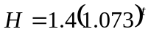. This is our health care equation.

Now, let’s use the health care equation to estimate the amount of money that will be spent on health care in the United States in the years 2005, 2010, 2015 and 2020.

2005 is 4 years after 2001, so we want to know the value of H when t = 4. Put 4 into the equation for t and se what comes out.
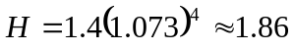 trillion dollars.

Now, 2010, 2015 and 2020 correspond to t = 9, 14 an 19 respectively. Put those values into the equation for t and see what comes out for H.
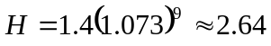 trillion dollars
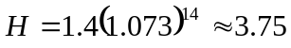 trillion dollars
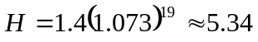 trillion dollars

Put all of the values of the equation together to make a table

t H
0 1.4
4 1.86
9 2.64
14 3.75
19 5.34.

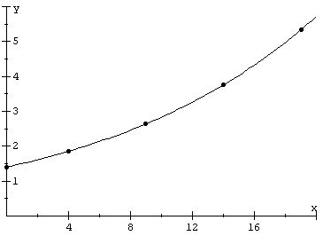
If we plot these points we can get an idea of what the graph of the equation will look like. This is a pretty typical shape for the graph of an exponential function. The graph grows faster and faster as we go to the right because it always grows by the same percentage, and what we are taking a percentage of gets bigger and bigger.

Exponential functions can be used to describe any relationship between variables in which the dependent variable grows by a fixed percentage whenever the independent variable increases by 1. Exponential equations can also be used to describe any relationship in which there is a fixed percentage decrease.

Example 5.1.1: David made a stock investment that hasn’t turned out so well. His original $1000 investment was worth only $900 after 1 month, only $810 after 2 months and had gone down to $729 after 3 months. This investment is decreasing exponentially. That is, the change in value is by the same percentage every month. What is the percentage decrease each month?

Solution: In the first month, the stock lost $100 in value. The value dropped from $1000 to $900. We need to know what percentage of the original value this drop represents. To find out, divide the amount of the change, 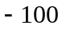, by the original value, $1000: 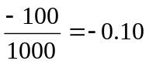 and change this to a percentage, 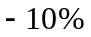. The stock dropped in value by 10% in the first month.

Did the same thing happen in the second month? In the second month, the stock changed in value from $900 down to $810. That’s a change of 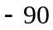 dollars. Divide the change by the value at the beginning of the month to get the percent change. 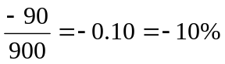. Yes, the stock dropped in value by 10% in the second month also.

In the third month, we had a change from $810 down to $729. That is a change of 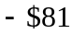. That represents another change or . ■

Example 5.1.2: Write an equation that shows the relationship between the time since David bought his crummy stock and the value of the stock, assuming that the pattern of changes in the stock’s value remains the same.

Solution: Let t be the time, in months, since David made this lousy investment. Let V be the value of the stock. Since V changes by a fixed percentage every time t increases by 1, the relationship between these two variables is exponential, and we can use our standard exponential equation template.
V is the dependent variable and t is the independent variable. The starting value is the value of the stock at the time that David bought it, $1000. The tricky thing to figure out here is the growth factor.

First of all, it seems silly to call it a growth factor when the value of the stock is shrinking instead of growing. It’s okay, though, the form of the equation is the same. Remember that the growth factor is the number that you multiply times this month’s stock value to get next month’s stock value. It is tempting to say that the growth factor is 10%, but that would be a mistake. 10% represents the amount of the value of the stock that is lost. We want to know what percentage of the stock’s value is retained. If it lost 10% of its value it must have kept 90% of its value. That number is our growth factor. Next month’s value will be 90% of this month’s value.

Fill in the blanks and we have an equation that we can use.
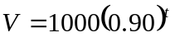
This is the equation for David’s silly foray into the world of investing. ■

Note that in both of our previous examples, the difficult thing to calculate was the growth factor. That was where we needed to invest the most thought. It is useful to think of the growth factor as whatever number you multiply times the dependent variable to get the new value of the dependent variable when the independent variable increases by 1.

If you wish, though, you can remember the following steps for calculating the growth factor if you know the growth rate.

First, write the growth rate as a decimal, call it r. If the dependent variable is growing, then r should be a positive number and if the dependent variable is shrinking, then r should be a negative number.

Then calculate the growth factor as 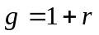. Remember that if the dependent variable is growing, then the growth factor is a number greater than 1. If the dependent variable is shrinking, then the growth factor is a number less than 1.

Example 5.1.3: Darlene is a patient in the Metropolitan Scientific Research Institute, or MSRI (pronounce ‘misery’). She is being administered a painkiller intravenously. She was initially given a dose of 100 cc of the painkiller. Each hour, her body eliminates 20% of the painkiller from her bloodstream. Make an equation that shows the relationship between the time since she received the painkiller, and the amount of the painkiller that is still in her blood. When the amount of the painkiller drops below 20 cc, she will need another dose. How long will it be before this happens?

Solution: Let P be the amount of the painkiller that is in Darlene’s bloodstream and let t be the time, in hours, since it was administered. Since P is changing by a fixed percentage every time t increases by 1, the relationship between t and P is exponential. Use the standard equation
The independent variable is t and the dependent variable is P. The starting value is 100. All we need to think about now is the growth factor. After 1 hour, her body will have eliminated 20% of the painkiller that she started with. So the growth rate is r = –0.20 as a decimal. The growth factor, then, is 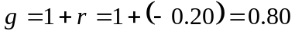. Each hour her body keeps 80% of the painkiller that was in her body.
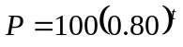

Now we can answer the question of how long it will take for the amount of painkiller to drop to 20cc. We want to know the value of t that corresponds to P = 20. That is, we want to solve the equation 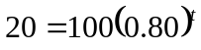. Sadly, equations of this form, where the variable is in the exponent, are not among those we are algebraically equipped to solve (yet!). So we will have to do this one by successive approximations or by graphing.

How much painkiller is still in Darlene’s bloodstream after 2, 4, 6 and 8 hours?
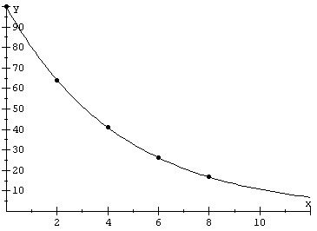
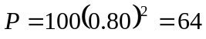
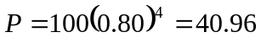
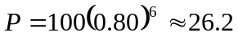
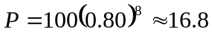
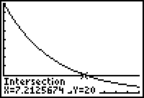
We are looking for 20 cc to come out of the equation, so we know that the value of t must be somewhere between 6 and 8. If we keep doing these successive approximations, we can eventually find that when 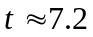, P is about 20, so about 7.2 hours after the first dose, Darlene will need another one. ■

Example 5.1.4: The population of Buenos Aires, Argentina t years after 1950 is approximated by the function 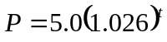, where the population P is measured in millions of people. What are the significance of the two constants in the equation?

Solution: The number 5.0 is the starting value. It is measured in the same units that P is measured in and it gives the value of P corresponding to t = 0. Since t represents the number of years since 1950, the population of Buenos Aires must have been 5.0 million people in 1950.

The number 1.026 is the growth factor. That is the number that we would multiply by the population in 1950 to get the population in 1951. So the population each year will be 102.6% of the population in the previous year. This means that the population is growing by 2.6% every year. ■

